MEMORANDUM
TO: Town Center Project Committee DATE: 11/16/2018

FROM: Travis Pryor PROJECT NO.: 14116A
Town Center Improvements Concept Plan
SUBJECT:

BACKGROUND

PROJECT GOAL
To improve the Town Center for the benefit of the entire community, enhancing physical, social and environmental opportunities in a manner that is in keeping with Bremen’s character.

SITE CONDITIONS
The Town Office property (approximately 5.15 acres) and adjacent Library properties (approximately 0.85 acres) are located immediately adjacent to Waldoboro Road (State Route 32), near the intersection with Nobleboro Road The site is in the northeast region of Bremen. The properties are identified on Town Tax Map 10 as lots 30, 30-1 and 31. The entire Town is zoned as General District in accordance with the Town’s Land Use Ordinance enacted July 20, 2017.
The site consists of a variety of land use conditions including:
· Paved access drive
· Overhead electric / CATV
· On-site water wells and septic systems (Bremen currently has no public water and sewer supplies)
· Open lawn and field areas (including a ballfield area with a backstop in poor condition)
· Paved parking areas (approximately 14 spaces at the Town Office and 8 spaces at the Library)
· Two-story Library building and one-story Town Office building
· A small formal garden and flag pole next to the Town Office building
· Woods
· A small drainage swale overgrown with invasive plan material, between the ball field and the Town Office, leading into the woods
The site is generally divided by a change in grade of 14 feet across the approximate middle of the site, between the buildings and the lower ball field area. The properties surrounding the site are residential / undeveloped lands which are primarily covered by small residential structures, lawns and woodlands.
14116A – Town Center Improvements Concept Plan - Bremen, Maine
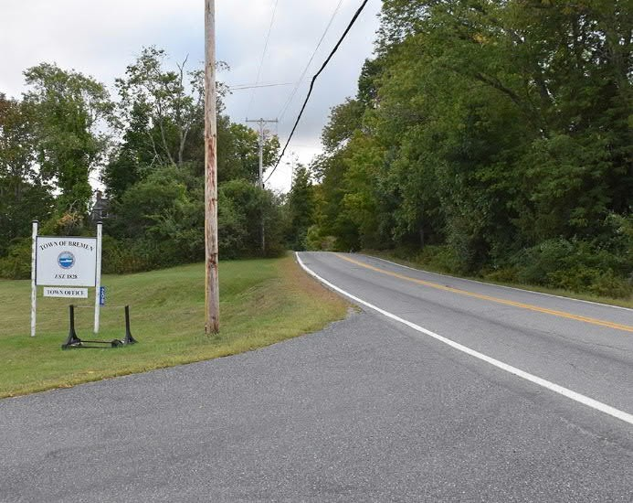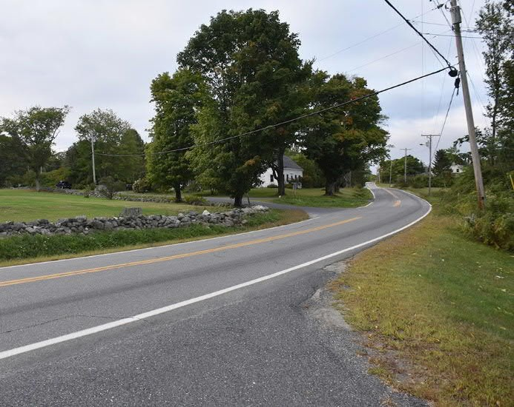

Rte 32 Approach Looking South from Access Drive Rte 32 Approach Looking North from Access Drive
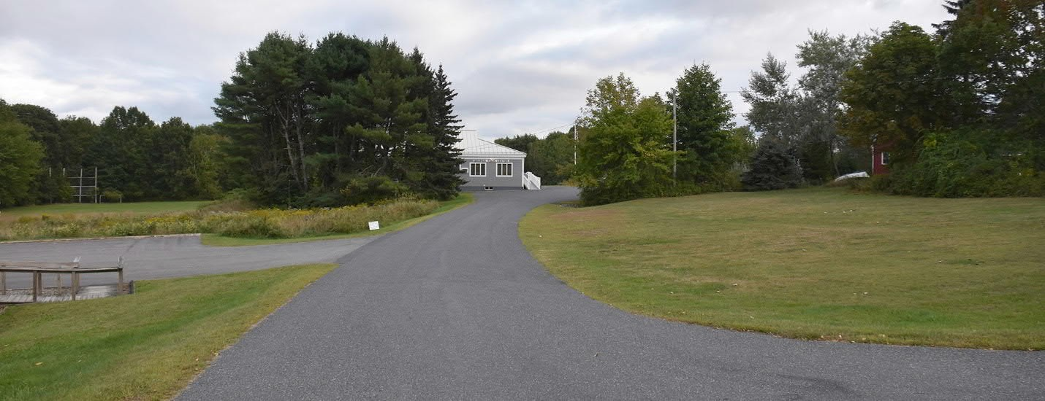

View Along Access Drive from Rte 32
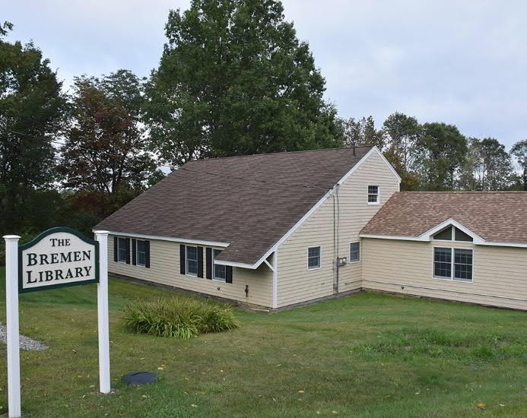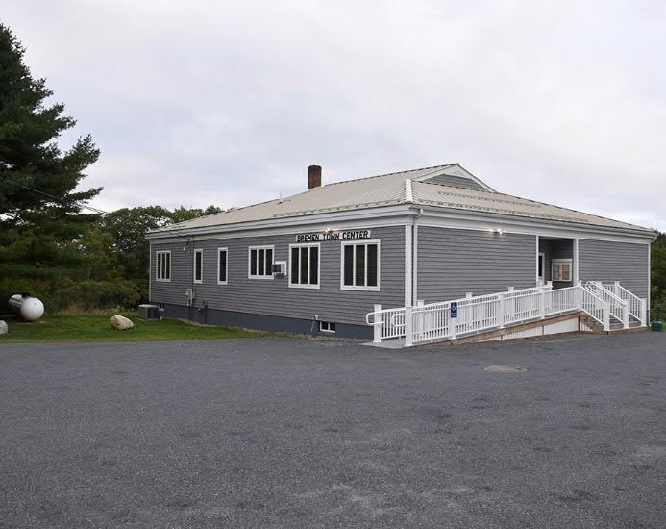

Town Office Library
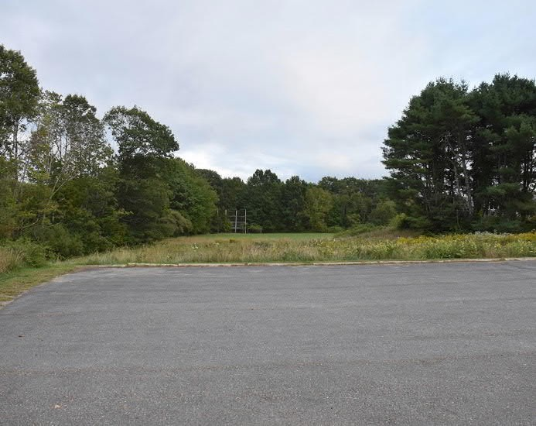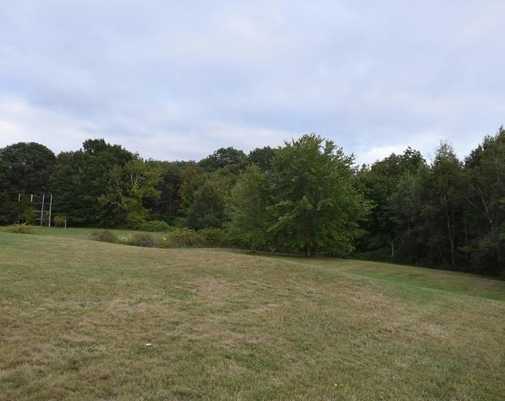

View from Library Parking Lot Looking East View from Town Office Parking Lot Looking East
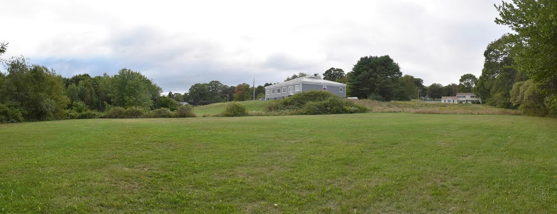

View from Ballfield Backstop Looking West
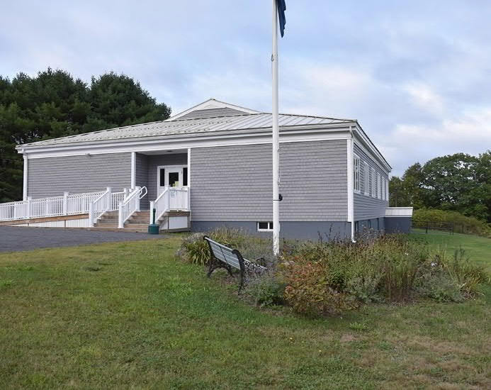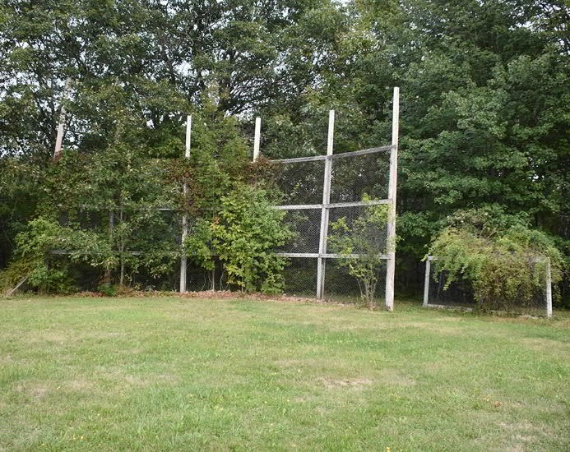
Garden and Flag Pole Next to Town Office Ballfield Backstop

PUBLIC INPUT
A significant amount of public input has been a key component of the development of this concept plan, from the initiation of the idea to explore ways to enhance the property for community benefit, to support for specific plan improvement elements, along with questions and concerns about how to best implement, operate and maintain the property in a sustainable manner that is respectful of Bremen’s rural, coastal community character. The following is a brief summary of each of the public input opportunities that informed this conceptual planning process:

INITIAL PLANNING IDEAS
After some general citizen discussions regarding opportunities to improve community engagement at the Town Office and Public Library properties, the Library Board and Conservation Commission met to begin exploring means to develop a plan for moving forward. This lead to the creation of the Town Center Project Committee, a part of the Bremen Conservation Commission Recreational Subcommittee, which developed a refined list of initial project improvement goals and identified the need for consultant assistance with development of a concept plan, intended to serve as a basis for implementation of the plan. The initial improvement elements included:
· Passive recreational walking paths for a variety of user abilities
· A small pavilion / gathering space close to the Library for multigenerational users and for general public entertainment gathering space
· Play space / structure(s) near the Library
· Story walk along the path(s)
· Pollinator garden(s)
· Native plantings
· Benches and picnic tables
· Preservation / restoration of the ballfield
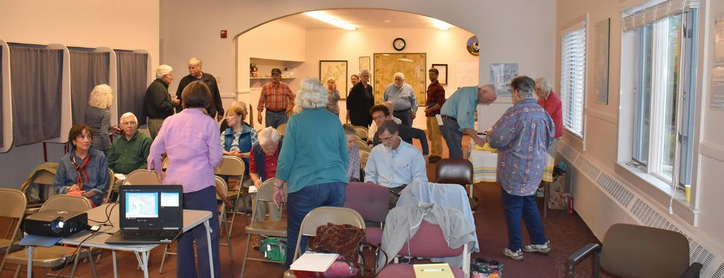
Public Input Workshop at the Town Office

PUBLIC SURVEY
The Town Center Committee created and submitted a town-wide public input survey to gather public input about the Town Center Improvements project. Out of the 61 responses received:
· 80% of the respondents lived within 1-5 miles of the project.
· Approximately 50% of respondents were 66 years of age or older.
· Approximately 33% of respondents were between 30 and 65 years of age.
· The remainder were between the ages of 12 to 29.
· Most respondents were year-round residents.
The public input provided gave a wide-range of input. Some consensus themes and ideas from this input included:
· Interest in low maintenance facilities (mowed field for walking, picnics, flying kites, etc.)
· Maintain ballfield
· Dogs allowed
· Trails
· Why more trails? Maintain trails elsewhere in town instead
· Community garden (user fees?)
· Leave as is (How many people use it now?)
· Concerns regarding project costs (Construction, operations and maintenance)
· How many people may use it with improvements (Cost / benefit analysis?)
· Use lawn for passive recreation near Library
· Gathering space for public events
· No play structures
· Simple play / exercise structures
· Sledding hill
· Small pavilion
· Multigenerational play area
· Unique ideas: Ice rink; tennis court; pickle ball; basketball court; senior housing; coffee shop; and a Christmas tree.

DRAFT CONCEPT PLAN PRESENTATION
Three different concept plans incorporating a lot of the project improvement elements identified in the initial public input and Committee planning discussions were presented at a public workshop at the Town Office. The plan elements and layout options were discussed with the public to solicit feedback focused on consensus support and prioritization of specific plan elements. The priorities for the final concept plan included:
· Establishing an overall Theme / Design Aesthetic for the project that all of the final improvement elements should follow. (Bremen is rural and the plan should represent Bremen’s culture / heritage.)
· Walking paths, including a perimeter path, intermediate loops and extension into the woods.
· Pavilion / shade shelter
· Multi-generational recreational area / structures (Create a place for kids to develop a strong sense of community).
· Leave the ballfield as is for multiple sports / public gathering uses.
· Viewer seating set into the hillside overlooking the ballfield area
· Basketball court in combination with ice skating
· Sledding
· Gardens
· Site amenities (in keeping with the overall project design theme and as “icing on the cake”).

FINAL CONCEPT PLAN PRESENTATION
After consensus and prioritization was discussed at the draft concept plans public input workshop, the design was refined and a final concept plan was developed to reflect the majority of this input. The final plan was presented at a second public input workshop to receive additional input for consideration. Final plan review comments included:
· Consider pavilion / shade shelter as a future phase and potentially two structures, one at the play area and one at the ballfield. Try out picnic tables / benches first and see how the site is used before identifying final locations of these structures and/or if they are ultimately needed.
· Play area should include formal / small scale play equipment for toddlers and more natural play elements for older kids / adults.
· Consider impacts to neighbors, especially lighting and noise.
· Can paths be connected to trails on abutting properties?
· Is the planning process described somewhere and how does this project fit in with the Town’s Comprehensive Plan and Land Use Ordinance?
· What are the maintenance and operations costs for the proposed plan?
· How much public gathering / scale of events is too much?
· Some consider the Town Center as the area around the Fire Department / Church.
* Contact the Town Center Committee for additional public input documentation.

PLAN ELEMENTS
Based on the project improvement goals, public input and technical design review, the following plan elements were incorporated into the final concept plan. Perhaps key to the success of this project in the view of the public, will be the idea that the sum of these elements is more important than the projects “parts”. The first design development goal after the concept plan is completed, should be to establish a theme for the development of the property that is in keeping with the rural character of Bremen (i.e. a coastal, maritime theme).
The following technical design and regulatory standards were considered for all Town Center improvement elements where applicable:
· Physical site conditions / constraints
· Americans with Disabilities Act (ADA) Accessibility Standards
· Site safety / crime deterrence
· Environmental / zoning regulations
· Parking
· Signage
· Utilities (Water, sewer, electricity, Data / Wi-Fi)
· Operations and Maintenance
· Construction costs
· Phased Implementation
The site has no state and federal environmental regulations identified during the concept plan development that are anticipated to affect the implementation of the project elements considered. The proposed uses for the site are consistent with the Town’s Comprehensive Plan and Land Use Ordinance.
The individual prioritized concept plan elements are described below in further detail. Initial discussions have focused on first phase implementation of the paths and then subsequent phased implementation of other project elements as funding becomes available. Initiatives such as the Town Center Improvements project often are implemented in phases and careful consideration should be made going forward in terms of an appropriate approach to phased implementation. In coordination with implementation of the paths, it is recommended that landscape restoration be implemented at the same time, and removal of invasive plant species happen prior to implementation of the paths. If exercise equipment, benches, etc. are anticipate along the paths, then those items may be considered for implementation at the same time to limit disturbance of the paths during subsequent construction phases. Play areas and public gathering spaces are likely to follow in subsequent phases, with the construction of viewer seating and pavilion / shade shelters as final plan elements to implement. Other site features such as improved signage, lighting, utilities, bike trash receptacles, etc. should be discussed throughout the phased implementation efforts to make sure there are appropriate locations for such amenities at a future date if funding is not available to accommodate them during the initial plan implementation efforts.

PLAY
The plan focused on two types of play systems. Small scale, pre-manufactured structures for younger children, and natural play structures for older kids and adults. The pre-manufactured structures can range in purchase and installation costs from $10,000 to $100,000 and up. They require level graded and well drained areas, typically including a fall-safe surface material such as recycled rubber matting or wood chips. Natural play elements can range in cost from $0 to $50,000 depending on if the materials (rocks, logs, earthwork) and construction labor can be donated, versus purchasing materials and hiring professional contractor to construct it. There is typically a greater range of opportunity to build some or all natural play elements through volunteer labor and donated materials, while pre-manufactured play structures may be able to be supported in part or in whole through grant funds with some level of local match often required. Natural play elements do not necessarily require level graded areas, or fall-safe surfaces, however the area should be well drained.
The play area should be located within the Town Center property at a location that is visible and is ADA accessible, with consideration of location in proximity to adjacent access drives and parking lot areas where fencing may be desirable for additional site safety. Depending on the level of use and adjacent community gathering that may takes place near the play area, a pavilion or shade shelter as a future phase improvement would be appropriate to locate next to it.
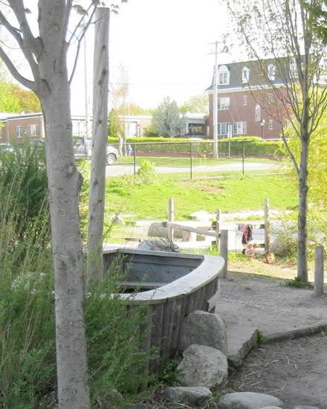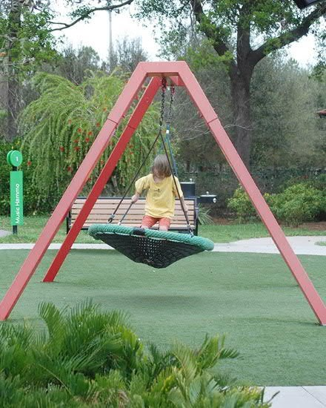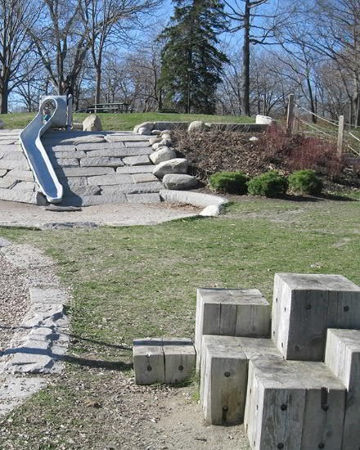
Examples of Built and Natural Play Structures

GARDENS
There is ample opportunity to enhance the landscape of the properties in support of pollinator gardens and other naturalized landscape areas. The existing lupine field adjacent to the Library parking lot was noted throughout the public input process as one of the key existing features of the site that the public was in strong support of preserving. Expansion of this type of landscape, promoting other meadow areas, is a relatively low-cost improvement ($100s to $5,000) with minimal operations and maintenance requirements. The Town currently pays to have the majority of the property maintained as mowed lawn and while the ballfield and any new mowed paths will require such ongoing maintenance, the area can be significantly reduced to only needing mowing once a year in the fall for areas that are allowed to naturalize along the paths, near the sledding hill, along the perimeter of the ballfield and in buffer areas along the edges of the property, including Rte 32.
The other initiative to maintaining a healthy landscape with native materials will require initial labor and or maintenance costs to eradicate invasive plant species. These are mostly present along the drainage swale between the ballfield and the Town Office building and will require initial cutback and then successive cuttings for a few years, or consideration of herbicides in-lieu of cutting if acceptable to the Town. Such herbicide use is not recommended immediately adjacent to other property areas that are expected to receive frequent use so this method should be considered as an initial phase improvement to the property prior to implementation of other elements such as the paths or play area.
Theses gardens in combination with the paths and in support of adjacent Library activities could also incorporate story walks throughout the landscape. Story walks provide for outdoor educational opportunities, focused on books with themes that are often relevant to the surrounding landscape and cultural heritage. These story walks are often temporary and are at little to no cost to install and maintain, if materials are either donated or if not, printing, lamination and mounting on wooden stakes by the Town at costs on the order of $100-$300 are anticipated.
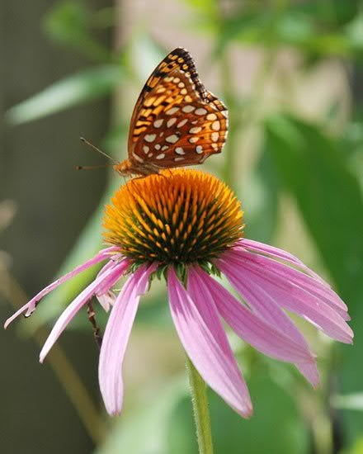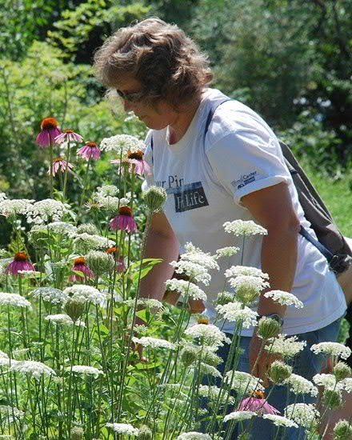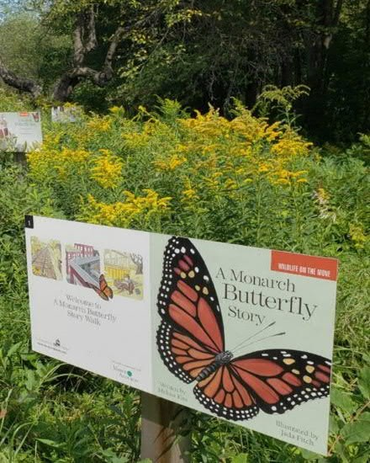
Examples of a Pollinator, Native Landscapes and a Story Walk Page

PATHS
There are a few types of paths anticipated for implementation at the Town Center. These paths are focused on recreational use by a variety of ages users of varying levels of physical ability.
The primary loop path is intended to be ADA accessible. The surface to meet this goal will either be paved or a hard-packed gravel / stone dust material. The path should be between 6 to 8 feet in width. As laid out in the concept plan and including the gravel access drive from the Library parking lot to the lower ballfield area, the loop is approximately ¼ mile. This path is anticipated to receive the most use and should consider opportunities for site amenities such as benches, and exercise stations sited along the path. Costs for construction of this path by a private contractor are anticipated to be between $25,000 to $50,000.
Secondary paths adjacent to the primary loop path are intended to connect to adjacent site elements such as the play area, sledding hill, parking and picnic areas. These paths are anticipated to be mowed or surfaced with woodchips and to be bordered along the majority of the path segments by pollinator gardens and other naturalized landscapes. The paths should be 5 to 6 feet in width and may have steeper areas of grade than those meeting ADA accessibility guidelines. These paths will have little to no construction costs and will have ongoing maintenance costs in terms of mowing which should already be accounted for in the property’s current mowing program budget.
A path through the woods is an opportunity to provide a greater level of challenging recreational opportunity for park users who can traverse steeper terrain. This path will likely be surfaced with woodchips or gravel and should be 4 to 5 feet in width. This path may have steeper areas of grade than those meeting ADA accessibility guidelines. Costs for this path will likely be relatively small, $1,000 - $5,000 for gravel or wood chip materials plus selective clearing through the woods, which may be readily accomplished by local volunteer labor and donated materials.
Cost estimates for site amenities such as signage, benches, etc. will be better defined when a final theme for the overall park and appropriate site materials is selected. For example. A log bench may cost approximately $250 to $500 or may be something that someone can donate locally, while a decorative metal bench set on a concrete leveling pad may cost between $2,000 to $4,000.
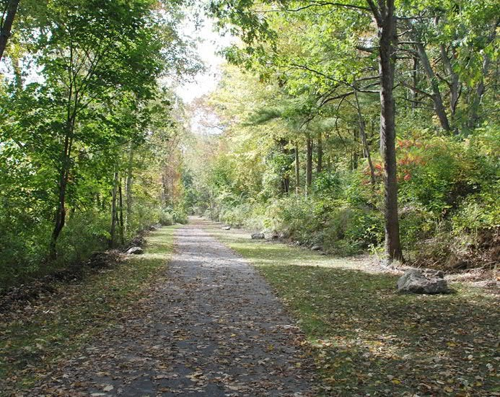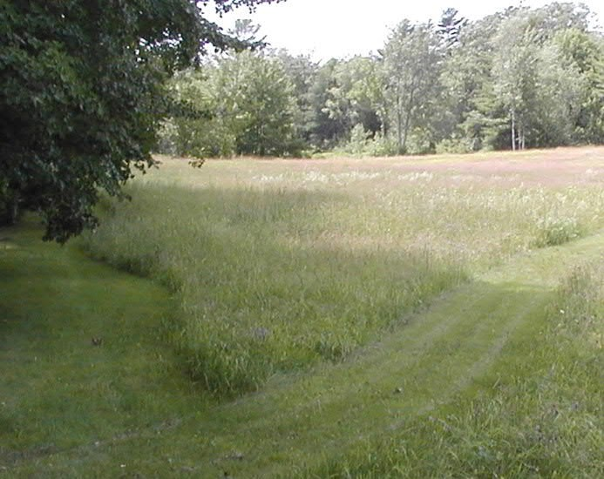
Examples of a Paved ADA Accessible Path and Mowed, Non-ADA accessible Path

OUTDOOR FITNESS / PUBLIC GATHERING
The ballfield area is anticipated to be the primary location for organized outdoor fitness and public gathering opportunities. The field can serve as an area for a wide variety of outdoor sports and lawn games, as well as for public gathering events such as music concerts, art exhibits, public ceremonies, etc. The loop path surrounding the field can also include exercise stations for outdoor fitness that are readily accessible from the loop path and the ballfield area. The costs for maintaining and operating the ballfield as lawn area are currently covered in the Town’s annual property maintenance budget and if large gathering events are organized for concerts, art festivals, weddings, etc. the Town may want to consider a rental fee to cover potential lawn repair costs at a minimum, or perhaps establish a fee schedule that serves as a means of revenue generation to fund other Town Center Improvement elements and ongoing operations and maintenance costs of the overall facility.
The Town may want to consider taking advantage of the sloping grade between to Town Office and the ballfield by constructing seating into the hillside for viewers to congregate and observe the outdoor fitness and public gathering events. This seating could be as simple as maintaining the hillside as a mowed lawn area. Seating improvements could also consider incorporating rows of wood benches, or concrete / stone wall seating. Costs for these design elements range from minimal (mowing costs already accounted for in the Town’s annual property maintenance budget) to $15,000 - $50,000 for informal (wood logs) to formal (quarried granite block) seating.
It is recommended due to the distance from the access drive and parking lots to the ballfield, as well as the steep change in grade between these areas, that a narrow gravel access drive and hammerhead turnaround be constructed off of the Library parking lot to allow for vehicular transport of temporary material supporting public gathering events on the field (tables, chairs, music equipment, etc.) This access drive could be paved or gravel and also could be utilized as part of the loop path. Construction of this access drive is estimated between $10,000 to $25,000 depending on whether it is gravel surfaced or paved. A paved access drive will require less ongoing maintenance as the likelihood of surface erosion is reduced, while a gravel access drive is likely to experience annual erosion and rutting that will require ongoing maintenance.
The Town also has a sledding hill area in place adjacent to the ballfield and the Town Office parking lot. The grade of the hill does not need modification to accommodate sledding and there is a level runout area at the bottom of the slope before the grade drops off again in the wooded area below. Depending on the level of sledding use, the Town may want to consider adding some earthen berms at the end of the runout area where there is limited distance from the bottom of the slope to the wooded area (typically less than 150 feet in length) and in the case that the sledding hill sees a high amount of use, potentially by sleds for more than a single user. This area should be carefully signed and discussed with the Town’s insurance agency representative to assess the liability risks of this activity for the Town.
These Town Center Improvements elements are anticipated to be implemented in subsequent phases after the paths, play areas and picnic areas are constructed, depending on future user demand and interest in expanding such larger scale public gathering and fitness opportunities at the site.
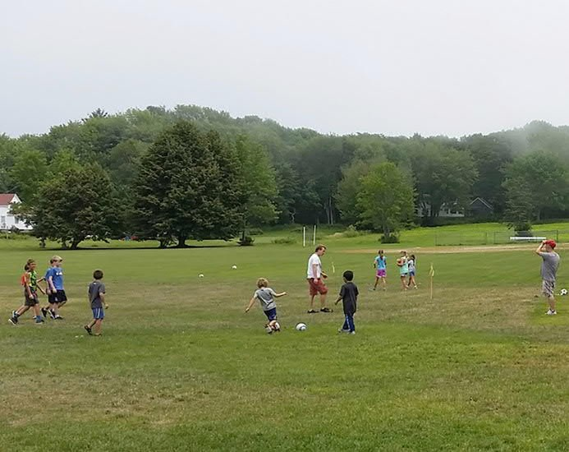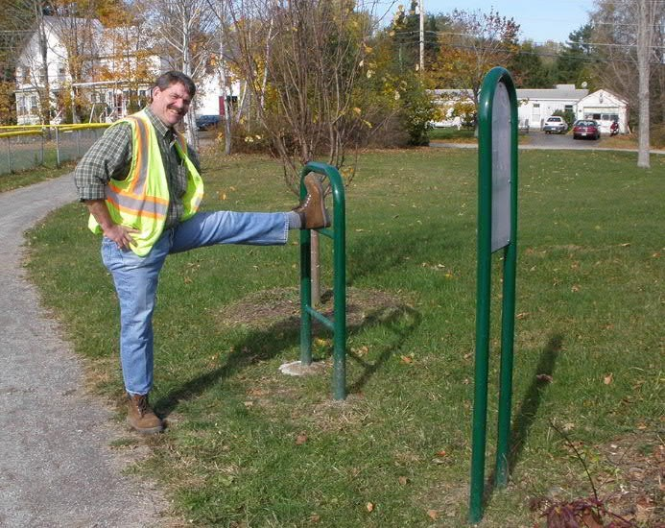

Examples of Field Sports and Exercise Stations
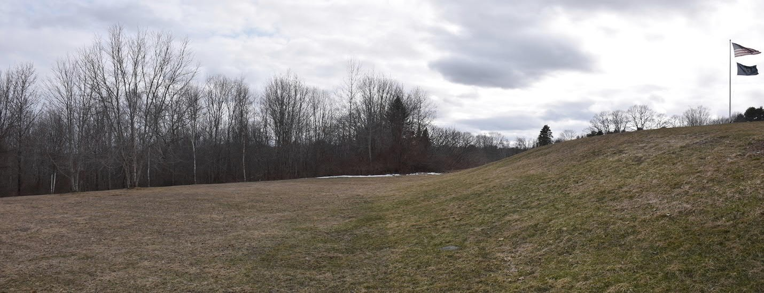

Examples Sledding Hill
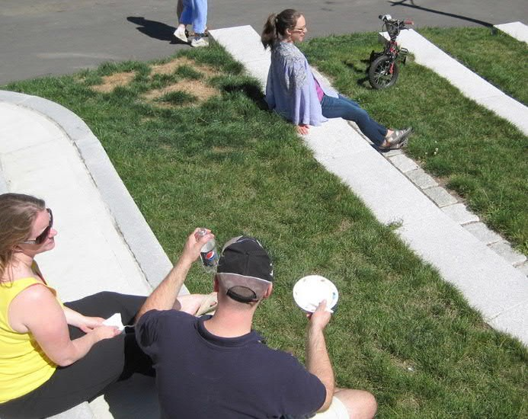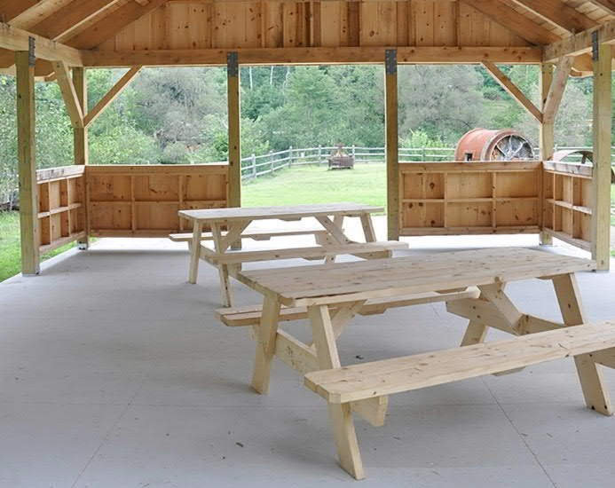
Examples of Viewer Seating and Picnic Tables with Shade Shelter

POTENTIAL FUNDING SOURCES
There may be a wide variety of capital funding and volunteer support resources to implement the Town Center Improvements project. Some of the plan elements may be implemented, operated and maintained through volunteer efforts, while other will likely require some level of capital investment for construction, operations and maintenance needs. Many of these require certain levels of local cash or in-kind services match when paired with state, federal and other philanthropic funding resources. Potential funding sources for the Town Center Improvements project to consider are listed below. Many of these sources have applications for funding requests and the funding program requirements should be reviewed prior to preparation of funding application(s):

Federal Recreational Trails Program
The program is authorized through the Federal Highway Administration and is administered by the Maine Department of Agriculture, Conservation and Forestry’s Bureau of Parks and Lands. https://www.maine.gov/dacf/parks/grants/recreational_trails_program.shtml
The federal share is up to 80% of project costs with the remainder provided from local sources (cash or state-approved in-kind services)

Federal Land and Water Conservation Funds
The program is authorized through the National Park Service and is administered by the Maine Department of Agriculture, Conservation and Forestry’s Bureau of Parks and Lands:
https://www.maine.gov/dacf/parks/grants/land_water_conservation_fund.html
The federal share is up to 50% of project costs with the remainder provided from local sources (cash or state-approved in-kind services)

Local Donations / Volunteers
There are often a variety of local grass roots fund raising campaigns that can successfully obtain capital donations and/or volunteer labor to construct trails. Opportunities to seek out this support could be at other public gathering events in Town, through online crowd funding, community meetings at the Town Office, at voting polls, etc.

Maine Army National Guard Units
Maine National Guard Units periodically have equipment and labor resources to construct various projects including some of the elements considered for the Town Center Improvements project (site grading, paths, building structures, picnic tables, benches, etc). Materials are expected to be provided locally.
http://www.me.ngb.army.mil/units/

Maine Conservation Corps
The Maine Conservation Corps has opportunities to provide volunteer labor and equipment to construction various Town Center improvement elements such as paths, viewer seating and potential other site amenities elements. Materials are expected to be provided locally. The program is administered by the Maine Department of Agriculture, Conservation and Forestry’s Bureau of Parks and Lands: https://www.maine.gov/dacf/parks/get_involved/conservation_corps/

Private Partnerships
Support might also come from other natural partnerships such as with local, non-profit organizations like the Library, the Medomak Valley Land Trust, the Medomak Valley Community Foundation, the Coastal Resource Center, etc. The Town may also want to consider creating a 501 3C non-profit organization that can focus directly on the project, applying for philanthropic endowment grants or other eligible state and federal funding programs behalf of the project.

National Recreation and Park Association
The National Recreation and Park Association administers a variety of funding programs and grant opportunities. These grant opportunities change periodically and cover a wide range of program elements considered for the Town Center Improvements project, from the Feed a Bee Improved Pollinator Grant to Baseball Tomorrow Fund grants.
https://www.nrpa.org/our-work/Grant-Fundraising-Resources/

Fee Use
While discussion of fees for program elements were discussed regarding ideas like a community garden, most of those types of improvements were not identified as top priorities for the Town Center Improvements project. There is the potential for the Town to collect fees for renting the facility for larger public gathering events as a way to generate income in support of the project, such as renting the ball field as space for weddings, family reunions, concerts, etc.

Maine Arts Commission
There may be interest an opportunity to incorporate public art into the Town Center Improvements elements, such as for site furnishings, signage, story walks, etc.
https://mainearts.maine.gov/Pages/Funding/Grants-Home

State Bonds
Although unpredictable, special state bond programs are sometimes funded by the legislature. Communities may be able to take advantage of such funding if appropriate to the Town Center Improvements project effort.

Municipal Bonds
More predictable and often misunderstood and increasingly underutilized are municipal bonds. This source of funding provides a greater level of local control and flexibility in funding projects that may not meet objectives of state and federal grant programs, while allowing local investors to put their financial resources into projects that are of particular value to the community.
Municipal bonds are used by local governments or territories, or other agencies (commonly including financial institutions and if the Town of Bremen is not familiar with this project, it is recommended that the Maine Municipal Association be contacted for peer assistance:
https://memun.org/

Project Canopy Grant
Project Canopy funds could be used for street tree plantings in the downtown or at the Town’s parks and public facilities. Funding and administration is through the Maine Forest Service and Growsmart Maine; the funding limit is usually $8,000, with a local equivalent cash and/or in-kind services match expected. This program has typically required attendance at a training workshop.
http://www.maine.gov/doc/mfs/projectcanopy/pages/resource.htm

Wild Seed Projects
The Wild Seed Project works to increase the use of native plants in all landscape settings in order to conserve biodiversity. At a minimum, they can serve as a resource for design of some of these Town Center improvement elements and may be a source of capital support as well.
https://wildseedproject.net/

